 | Pre-Release: v5.27 Release Enhancements

Agent Level Changes

Listing Input

Auto-Save for Listing Input
By popular demand! Listing Input form data will now save automatically in 60 second intervals allowing the user to return to the Input form with the recovered data.
Note: This feature will be set to active by default for the benefit of all customers and their Membership. .

CMA

Additional Supporting Documents
For greater flexibility, a variety of supporting documents are available for addition to CMA Presentation Packages.

CMA Presentations: Automatic creation of PDF
NOTE: As of this release, all Paragon CMA’s will now be generated, saved and e-mailed in a PDF format. This is necessary for the introduction of these new Supporting PDF Documents as well as the forthcoming enhancement which includes the ability for users to upload their own offline documents into a Paragon CMA.

Client Connect

Automatic update of Agent’s email Address
Functionality improvement - Auto-notification’s with a BCC Agent email address will automatically update when the email address is updated in the Agent Record.

Agent Level Changes

Auto-Save for Listing Input
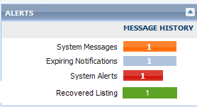
You asked for it, we delivered! Lisiting Input will now automatically save data at 60 second intervals. If the user leaves the Input screen open and either reaches the Session Time Out, closes the browser by accident, or closes the form tab without saving, a message will appear in the Alert Widget that there is a recovered listing.
This new feature only applies when adding a new listing and will not be availabe for Maintance.
Note: This feature will be configured as active for the benefit of all customers. .
Only a single instance of listing data will be recovered. The user can click the “Recovered Listing” icon and the following options will appear:
- Load Recovered Listing Data: Loads the recovered listing Input form allowing the user to continue to working from the last point of data retention.
- Remove: Gives the user the option to delete the recovered Input data if desired.
- Cancel: Alllows the user to close the modal window and continue working elsewhere in the system. Data is retained and can be acccesses at another time.
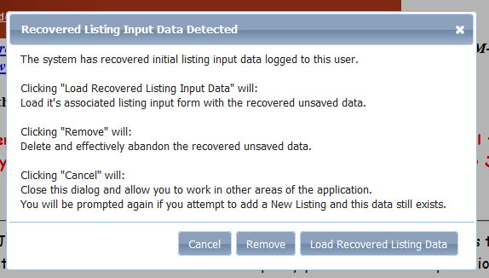

Accessing Listing Input with Existing Recovered Data
If a user attempts to begin a new listing when recovered data is present they will be provided the following options
- Load Recovered Listing Input Data: Loads Input form with recovered data.
- Continue Loading New Listing Input Form: Will load a new Input form.
IMPORTANT: If the user clicks this button the recovered data will be deleted from the system.
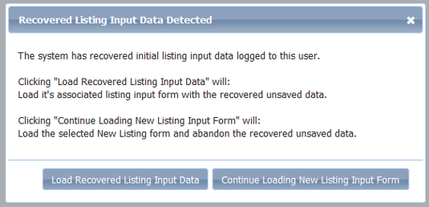

CMA

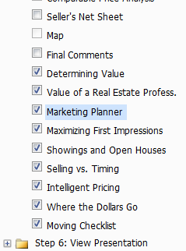
Additional Supporting PDF Documents
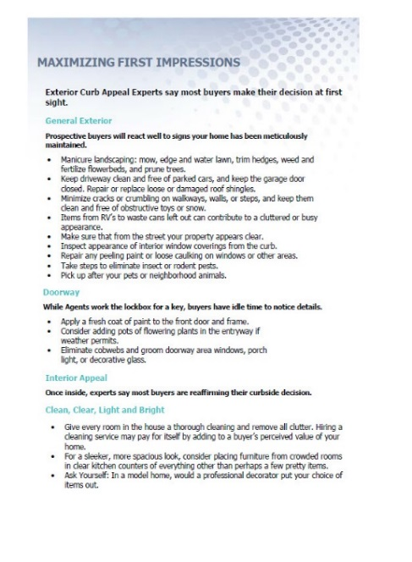

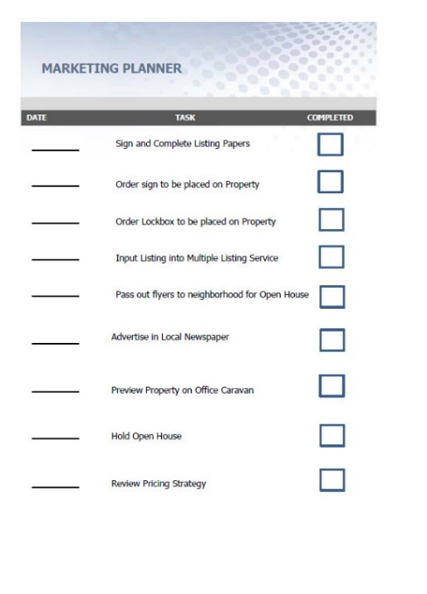

A variety of supporting documents are available for addition to CMA Presentations. These optional documents appear after “Final Comments” – and can be dragged and dropped within the menu tree for “Step 5: Presentation Setup”. These docs are not editable, but can be included in a CMA as needed. The selected CMA Theme is applied to each document as well.

CMA Presentations: Automatic creation of PDF
NOTE: As of this release, all Paragon CMA’s will now be generated, saved and e-mailed in a PDF format. HTML will no longer be available. This is necessary for the introduction of these new Supporting PDF Documents as well as the forthcoming enhancement which includes the ability for users to upload their own offline documents into a Paragon CMA.
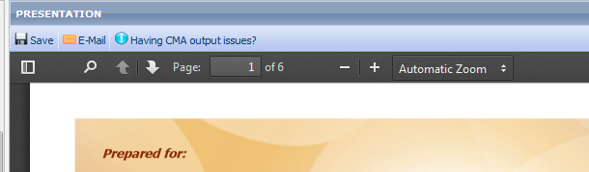
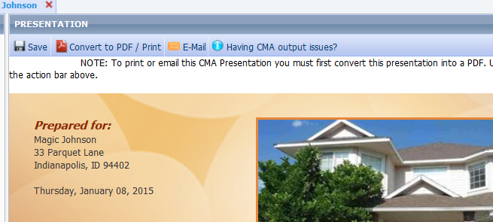
The Convert to PDF/Print has been removed as all Presentations will automatically generate as PDF’s.

Client Connect

Automatic update of Agent’s email Address
Client Connect notifications have been enhanced so that if the agent email address changes in the agent record, the BCC field for any auto-notification will automatically reflect the change.

Enhancements to Advanced Mapping

Clustering
- At higher zoom levels on the Map View, larger listing sets will display as clusters within circular icons which display the number of listing in the cluster.
- Clicking on a cluster icon zooms directly to that results set on the map. Clusters will appear within zoomed views where present

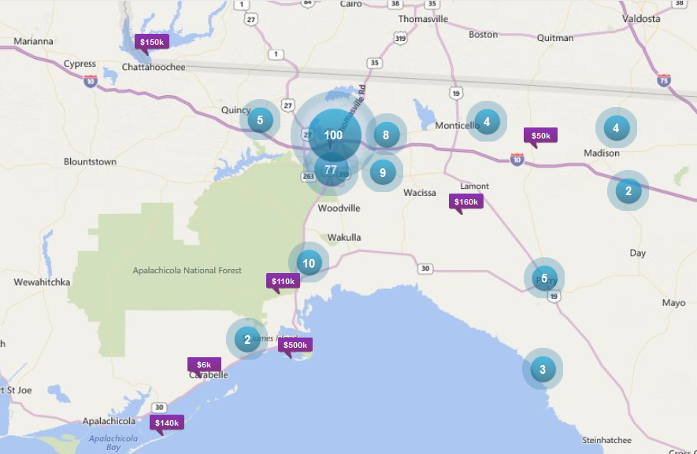
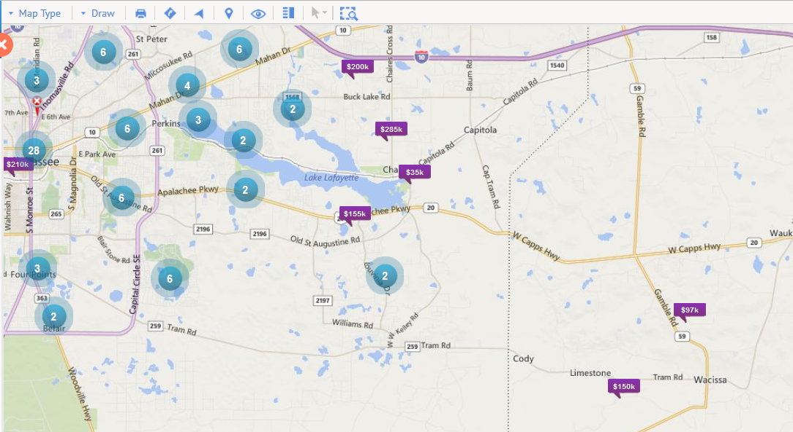

Sorting on Thumbnails
Sort options for MLS#, Price, Date, Status, Street, Zip and Sqft are available in the Thumbnail view.

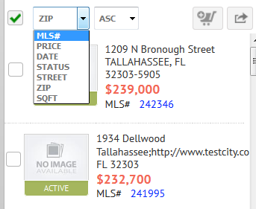

Paging controls
New Paging controls have been added to the bottom of the main Thumbnail View that displays when single listing icons on the map are selected.

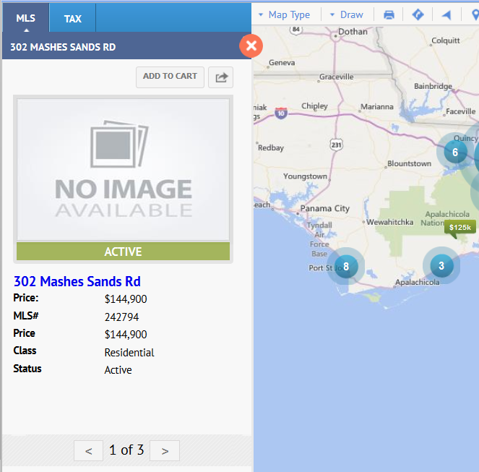

Click Address within the Thumbnail list zoom
, When hovering over the Address displayed in the Thumbnail List, users can now click on the address to zoom and center the property on the map.
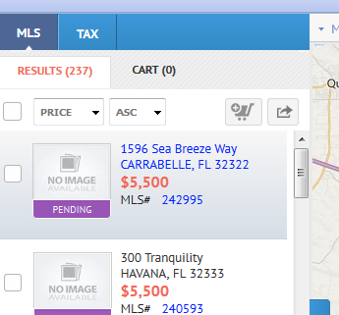
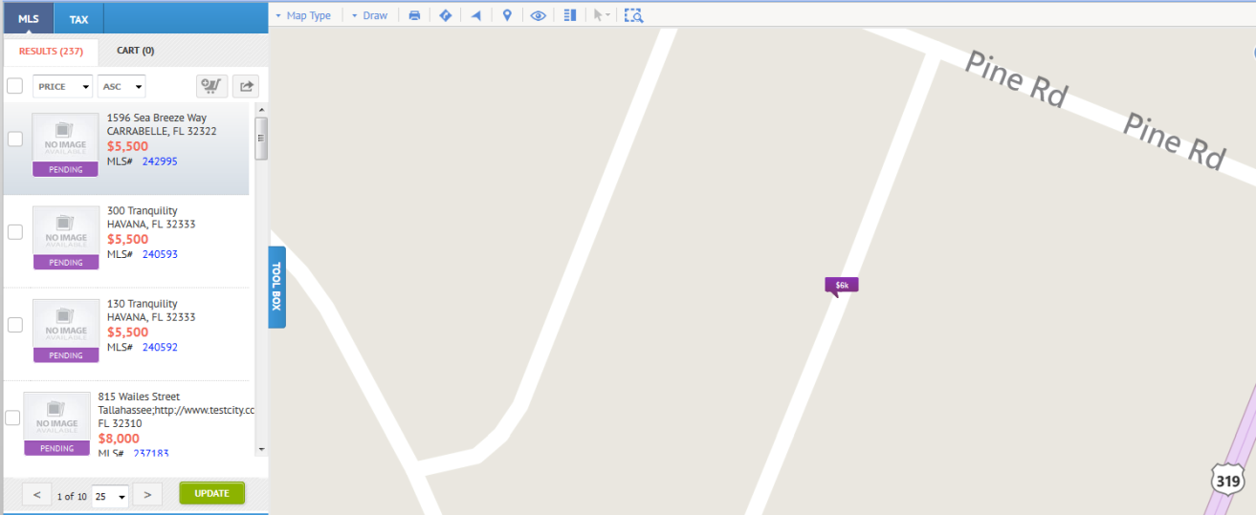

Additional Results Filtering within Map Shapes
A Map shape can be drawn over a group of Clusters to filter the results sets captured within the shape

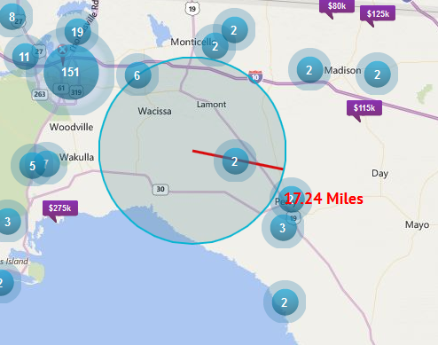

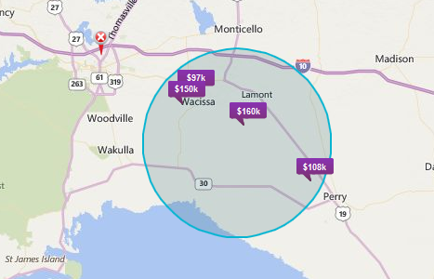

Two ways to view listings
- What you see on the map is what is displayed in the accordion control. If you move the map your list gets updated.
- Update option. All results returned. You can move the map or zoom in and the list doesn’t update until you click the update button. It is like taking a picture of the map and saying showing me what I see.

RETS enhancements closer to RETS 1.8 Standards (all RETS feeds and metadata will need to be refreshed). Please notify your third party vendor.

International phone number fields (all RETS feeds and metadata will need to be refreshed). Please notify your third party vendor.

