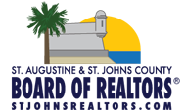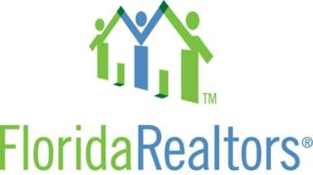

**Come to the Board Office on June 26th for instructions on Form Simplicity from a qualified Florida Realtors Instructor and get 3 CE Credits!**

**JUNE 26, 2015**

**9:00AM - 11:00AM**

**INSTRUCTOR: RUSSELL CURTIS**

**(Florida Realtors Staff)**

**3CE**

**Please Contact Erin Hughes at the Board to sign up for this class.**

**(P:) 904-829-8738**

**(E:) Staff@StJohnsRealtors.org**

**FORM SIMPLICITY 3CE**

**OBJECTIVE:**

**Students will learn how to create, manage and store all of the paperwork necessary for a real estate transaction. In addition, students will learn how to auto populate data from either their local MLS or Public Records. The Form Simplicity program will electronically manage transactions for long term storage as well as compliance.**