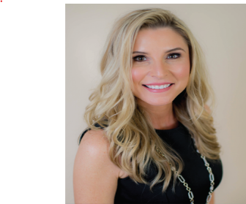

Thursday, March 3rd

9:00 am – 10:30 am

St. Johns County Board of Realtors Office

Carmen Richardson

Mortgage Advisor

Coast2Coast Lending

NMLS #375570

904.994.7003



**CLOSE ONE EXTRA DEAL PER MONTH USING FACEBOOK**

SIGN UP FOR THIS FREE UPCOMING REALTOR SUCCESS SEMINAR!

What could your business do with marketing that is cost-effective and easy to use? Learn how you can turn your everyday use of social media into a fun and easy way to make more money for your real estate business! Facebook sees thousands and thousands of buyers and sellers every day that need help with buying and selling homes. It’s time to put yourself in their view!

In this FREE 60-minute presentation plus Q&A, Carmen Richardson will answer all of your questions on leveraging Facebook to generate leads and closings. We will cover the following topics:

* Facebook Edgerank
* Hierarchy of Facebook Posts
* Selling on Social Media with the BELTS Method
  + Facebook Group Farming
* Facebook Third Party Posting
  + Whip Effect
  + List Building
  + Apps to Use
* Power of Video
* Plus Much More…